YOLO Model Comparison for Real-Time Polyp Detection
Updated multi-dataset comparison for the gastrointestinal AI final project (YOLO26n, YOLO11n, YOLOv8n, and YOLOv8s).

Decision Summary
The current multi-dataset experiment changes the interpretation of the previous Kvasir-only comparison. YOLOv8s obtains the best cross-dataset accuracy, with an external average mAP50-95 of 0.502, but it is substantially larger at 11.14M parameters. Among nano-scale models, YOLO11n has the best external average mAP50-95 at 0.481, narrowly ahead of YOLO26n and YOLOv8n.
For STM32MP257 deployment, YOLOv8n remains the primary demonstration model because its full-integer INT8 TFLite-to-NPU path has already been validated on the board. It runs on the STM32MP257 NPU at approximately 35.7 ms per inference, around 28 FPS. YOLOv8s is kept as the accuracy upper-bound reference, while YOLO11n and YOLO26n are compact alternatives for additional conversion tests.

Experimental Setup
Item | Setting
Training data | Multi-dataset training set: Kvasir-SEG, PolypGen positive cropped images, Hyper-Kvasir segmented positives, and Hyper-Kvasir lower-GI negatives.
Internal holdout | Held-out test split from the multi-dataset configuration.
External validation | CVC-ClinicDB, CVC-ColonDB, and ETIS test sets.
Task | Single-class polyp bounding-box detection.
Image size | 416 x 416 for all reported accuracy experiments.
Training schedule | 80 epochs, batch size 32, same endoscopy-domain augmentation and seed where applicable.
Metrics | Precision, recall, mAP50, mAP50-95, parameters, GFLOPs, and model weight size.
Deployment context | YOLOv8n full-integer INT8 is the currently validated STM32MP257 NPU deployment model.

Main Results
Model | Params (M) | GFLOPs | PT MB | Internal mAP50-95 | External Avg mAP50-95 | External Avg Recall | CVC mAP50-95 | ColonDB mAP50-95 | ETIS mAP50-95
YOLOv8s | 11.14 | 12.10 | 22.51 | 0.774 | 0.502 | 0.762 | 0.559 | 0.455 | 0.493
YOLO11n | 2.59 | 2.72 | 5.47 | 0.748 | 0.481 | 0.703 | 0.548 | 0.425 | 0.471
YOLO26n | 2.50 | 2.44 | 5.39 | 0.768 | 0.478 | 0.690 | 0.579 | 0.426 | 0.428
YOLOv8n | 3.01 | 3.46 | 6.24 | 0.756 | 0.465 | 0.720 | 0.536 | 0.408 | 0.452

Per-Dataset Accuracy Details
Model | Dataset | Precision | Recall | mAP50 | mAP50-95
YOLO11n | internal_holdout | 0.946 | 0.893 | 0.952 | 0.748
YOLO11n | cvc_clinicdb | 0.892 | 0.768 | 0.863 | 0.548
YOLO11n | cvc_colondb | 0.825 | 0.676 | 0.792 | 0.425
YOLO11n | etis | 0.873 | 0.663 | 0.757 | 0.471
YOLO26n | internal_holdout | 0.924 | 0.918 | 0.953 | 0.768
YOLO26n | cvc_clinicdb | 0.846 | 0.812 | 0.866 | 0.579
YOLO26n | cvc_colondb | 0.799 | 0.661 | 0.764 | 0.426
YOLO26n | etis | 0.708 | 0.597 | 0.685 | 0.428
YOLOv8n | internal_holdout | 0.942 | 0.928 | 0.959 | 0.756
YOLOv8n | cvc_clinicdb | 0.842 | 0.815 | 0.871 | 0.536
YOLOv8n | cvc_colondb | 0.824 | 0.650 | 0.774 | 0.408
YOLOv8n | etis | 0.710 | 0.694 | 0.751 | 0.452
YOLOv8s | internal_holdout | 0.952 | 0.940 | 0.966 | 0.774
YOLOv8s | cvc_clinicdb | 0.849 | 0.819 | 0.858 | 0.559
YOLOv8s | cvc_colondb | 0.792 | 0.731 | 0.808 | 0.455
YOLOv8s | etis | 0.833 | 0.735 | 0.803 | 0.493

Figures
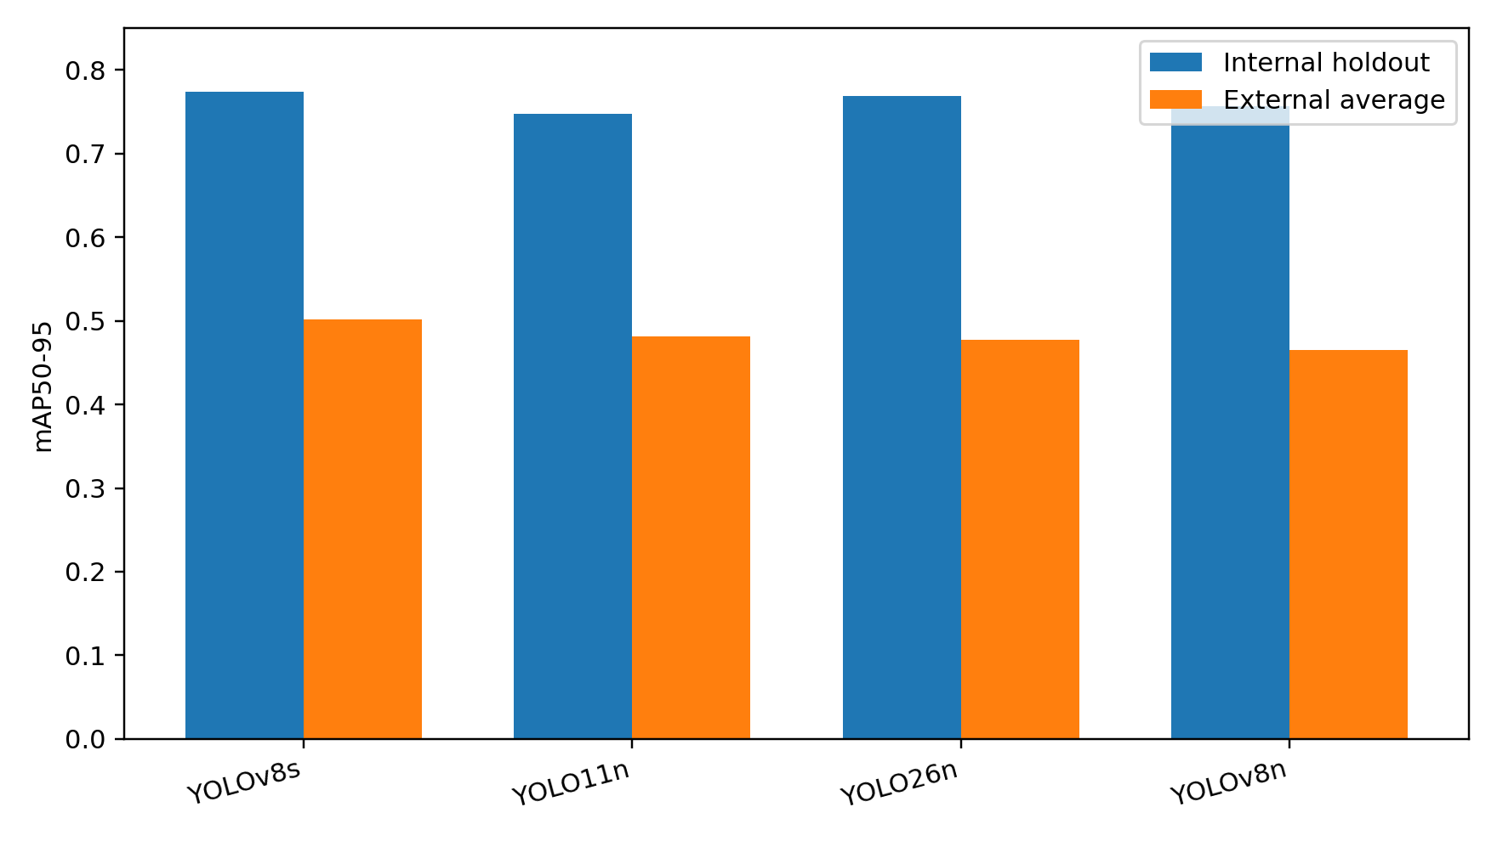
Figure 1. Internal holdout and external-average mAP50-95 under the current multi-dataset training setup.
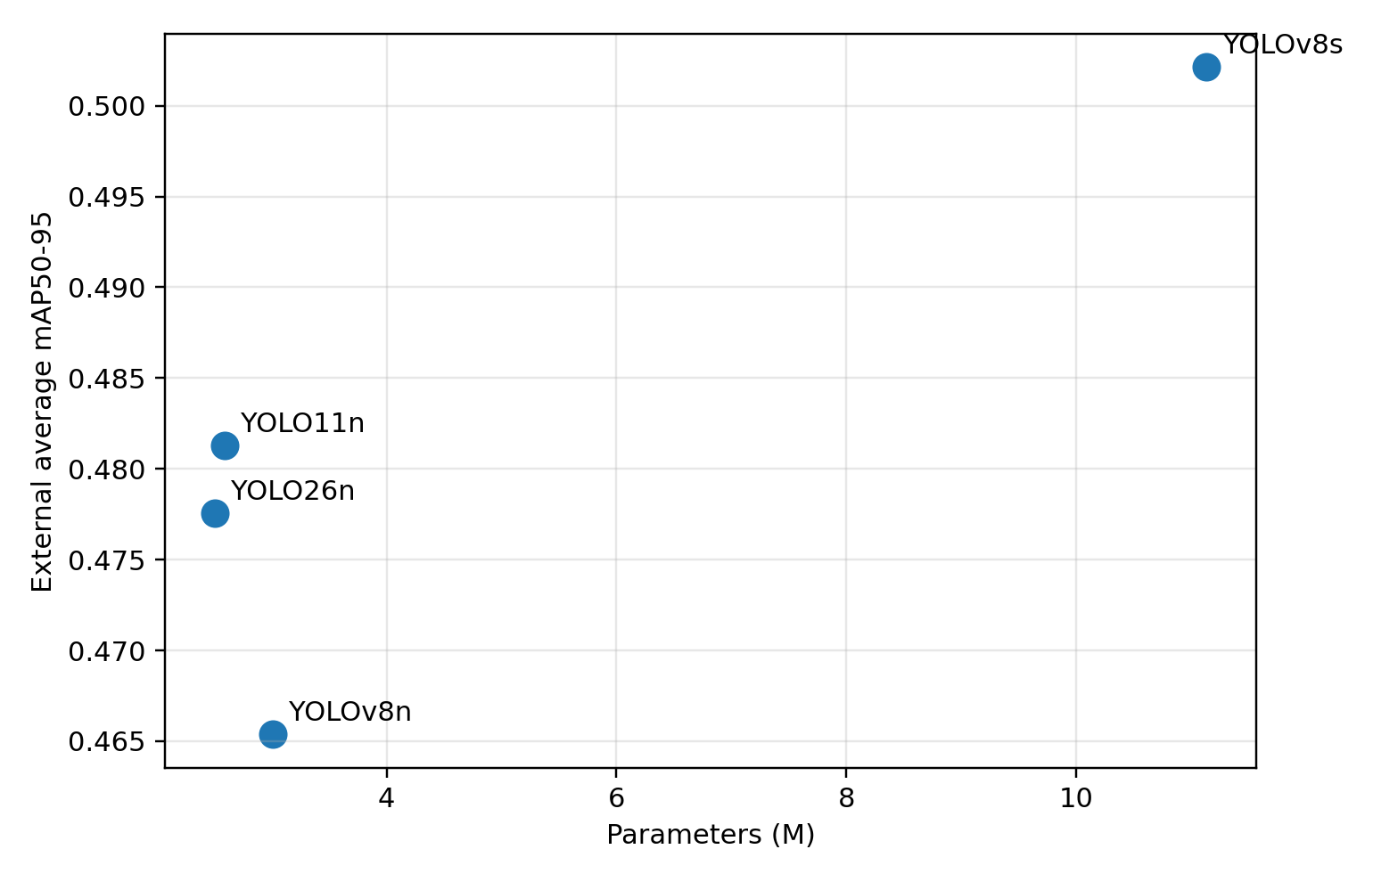
Figure 2. Parameter count versus external-average mAP50-95. YOLOv8s improves accuracy but at a much larger parameter cost.
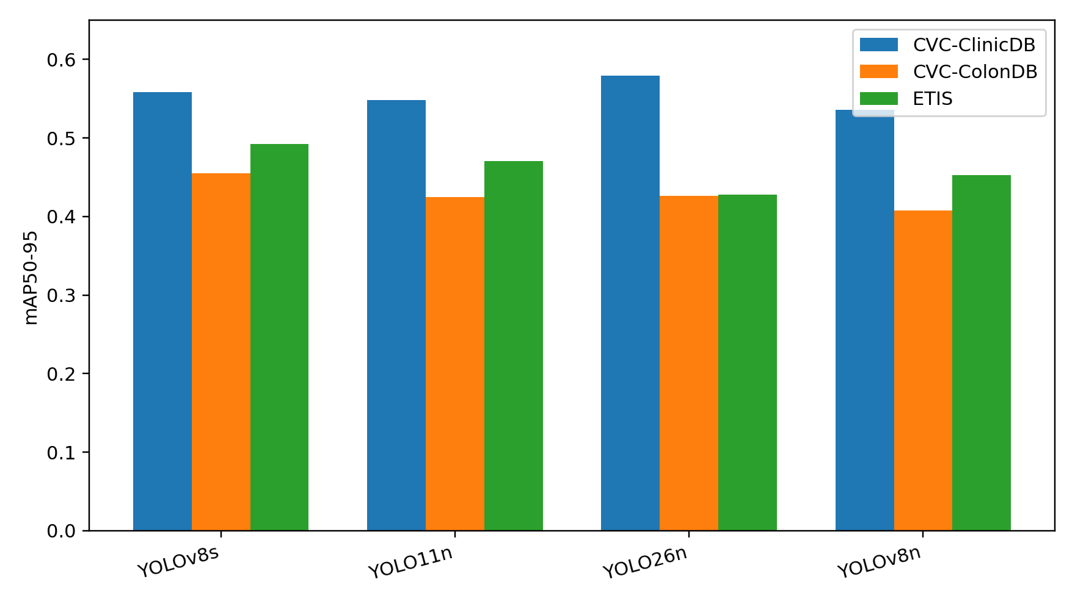
Figure 3. External dataset mAP50-95 comparison on CVC-ClinicDB, CVC-ColonDB, and ETIS.

Interpretation
The external datasets are the most important evidence for classroom justification because they test cross-dataset generalization rather than only within-distribution performance. The current results show that multi-dataset training improves the scientific strength of the project: the model is evaluated on multiple independent polyp datasets with different image characteristics.
YOLOv8s is the best pure-accuracy model in this run, but it is not the preferred embedded deployment candidate because its parameter count and compute are much higher. YOLOv8n is selected for the live STM32MP257 demonstration because its full-integer INT8 model has already been converted to NPU format and benchmarked successfully. YOLO11n is a promising compact accuracy candidate for future NPU conversion, while YOLO26n is compact but its tested INT8 NPU model was slower and less stable in video inference.

Generated Result Files
- runs/multidata_compare_eval_4models/model_summary.csv
- runs/multidata_compare_eval_4models/multidata_eval.csv
- runs/multidata_compare_eval_4models/multidata_eval.json
- runs/detect/runs/multidata_train/multidata_yolo11n_416/weights/best.pt
- runs/detect/runs/multidata_train/multidata_yolo26n_416/weights/best.pt
- runs/detect/runs/multidata_train/multidata_yolov8n_416/weights/best.pt
- runs/detect/runs/multidata_train/multidata_yolov8s_416/weights/best.pt

